GOVERNMENT COLLEGE OF NURSING, GSVM, MEDICAL COLLEGE CAMPUS, KANPUR

**REPORT ON WORLD AIDS DAY 2024**

ON 7/12/2024

VENUE: WAC HALL

TIMING: 2 TO 4 PM

**REPORT ON WORLD AIDS DAY CELEBRATION 2024**

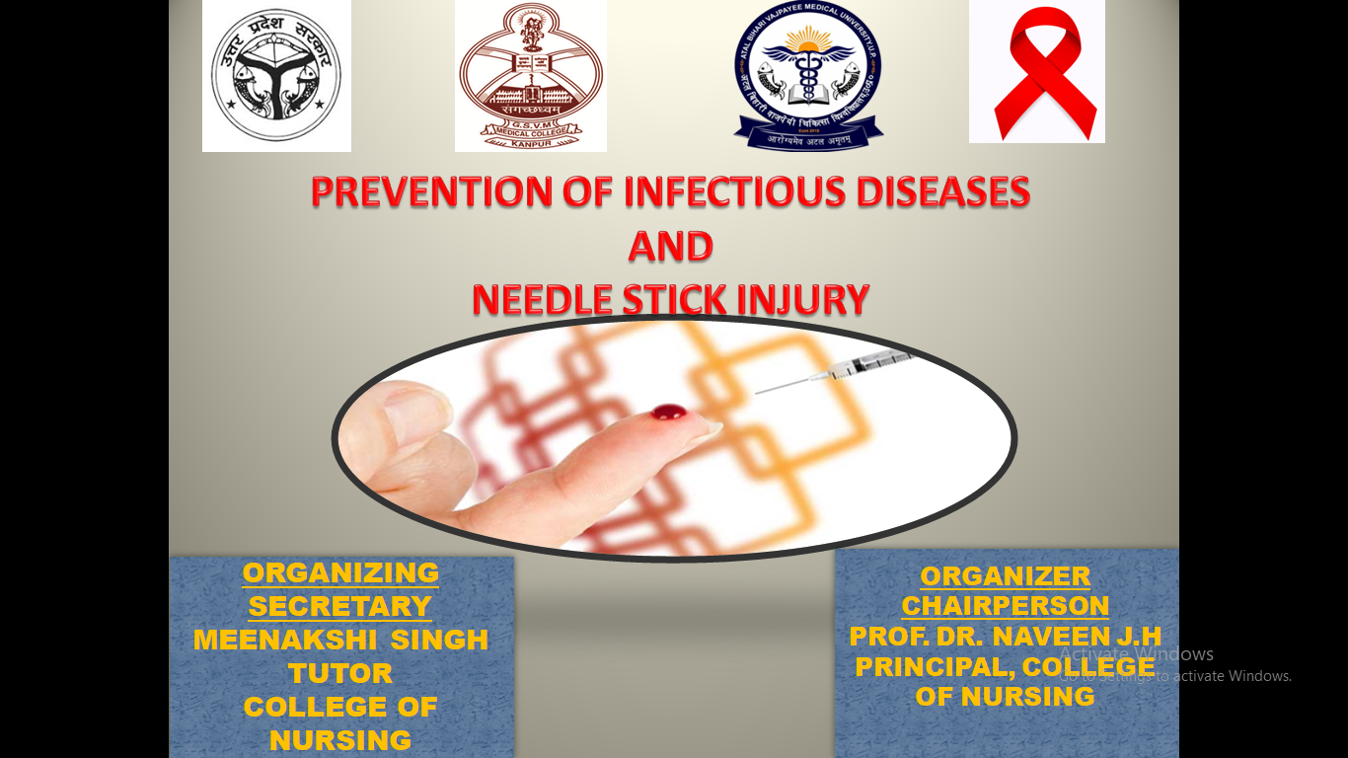

**SUBMITTED BY SUBMITTED TO**

MEENAKSHI SINGH PROF. DR. NAVEENA J.H

TUTOR PRINCIPAL

COLLEGE OF NURSING COLLEGE OF NURSING

KANPUR KANPUR

**REPORT ON WORLD AIDS DAY CELEBRATION 2024**

On 7-12-2024 government college of nursing, GSVM, medical college campus, Kanpur organized a Guest Lecture on WORLD AIDS DAY CELEBRATION, (theme take the right path- my health my right) regarding prevention of infectious disease and needle stick injury.

The program me was organized by Principal college of nursing Prof. Dr. Naveena J.H, as organizing chairperson and Mrs Meenakshi Singh, tutor, college of nursing as organizing secretary for the B.sc nursing students including 1 semester, 3rd semester and 4 th semester.

The programme was started by taking the blessings from lord sarawasti maa by our principal sir, chief guest, and guest of honor and along with all the faculty members.

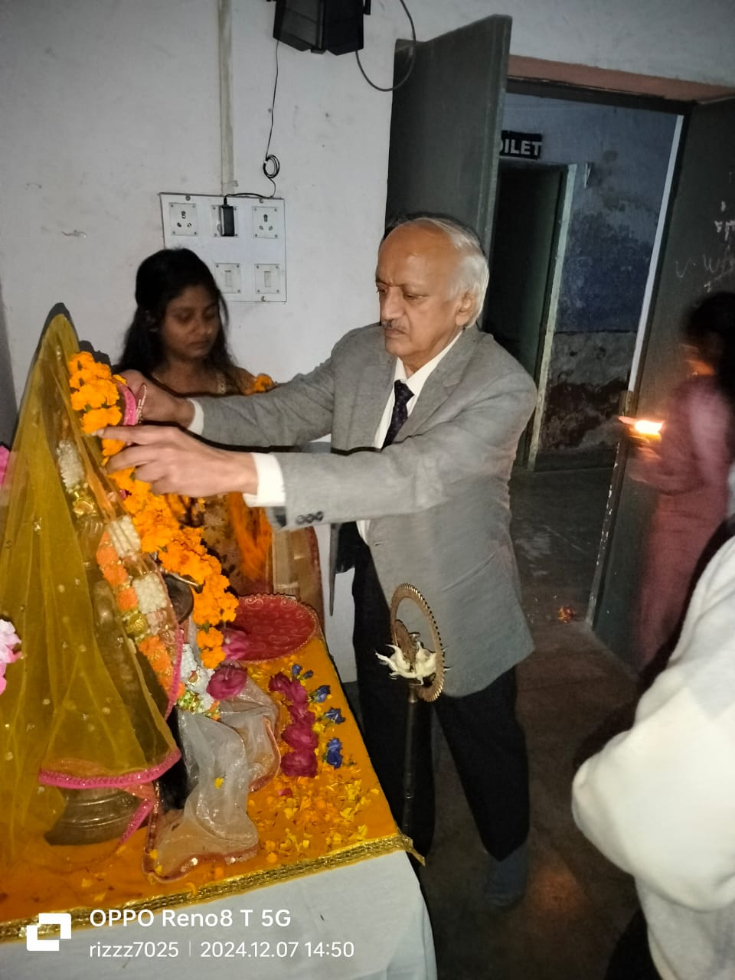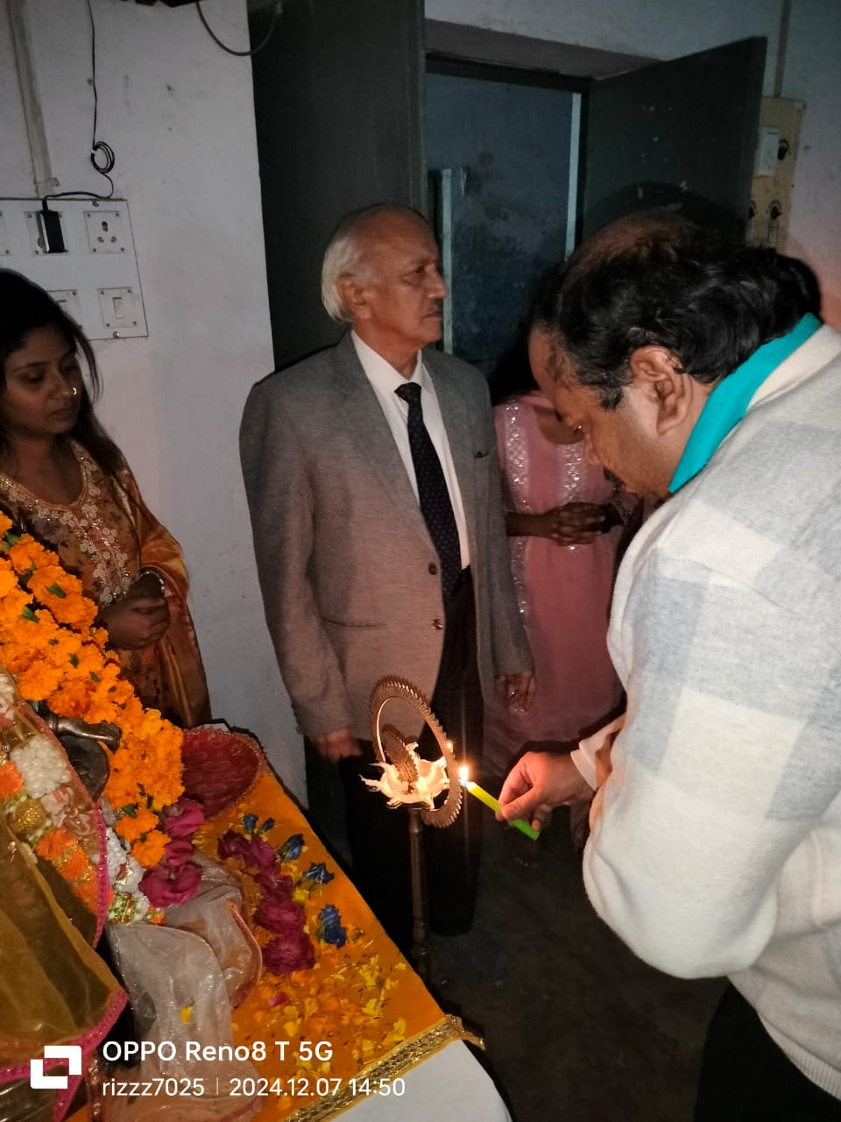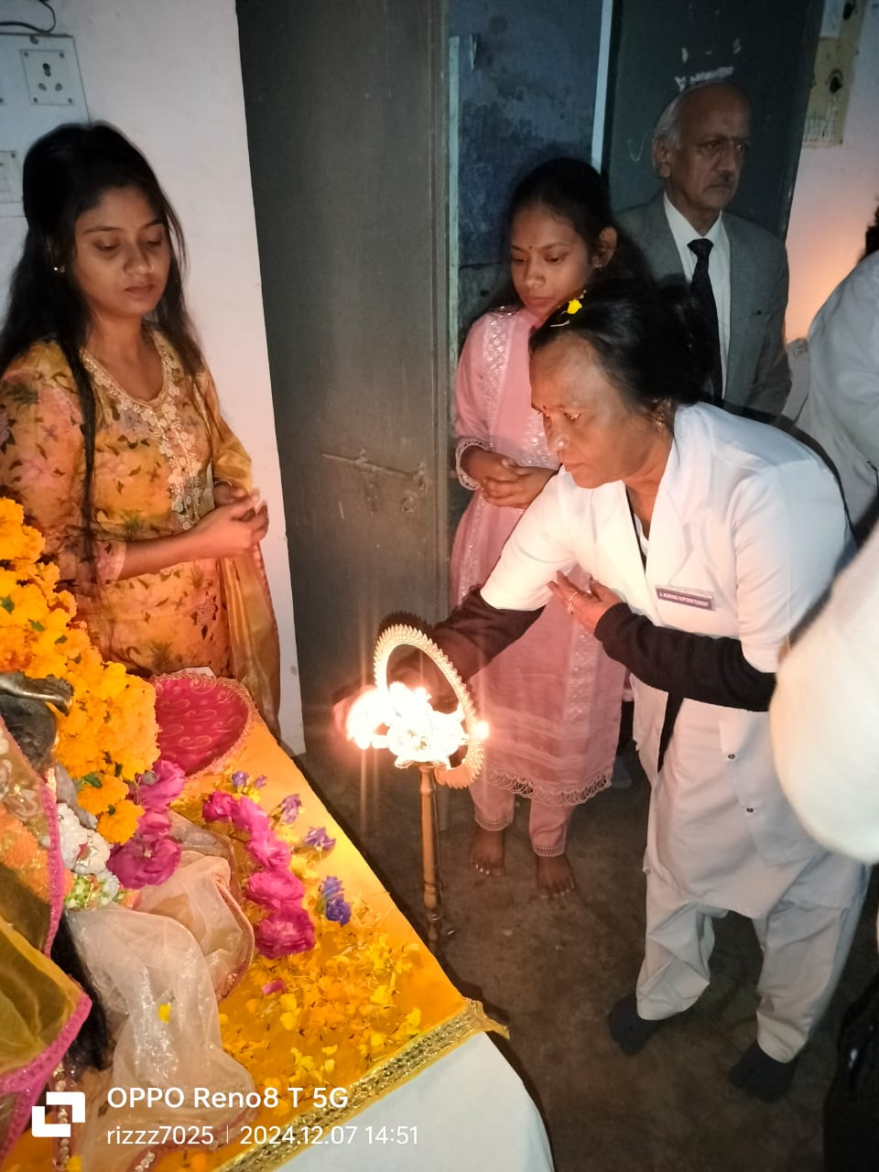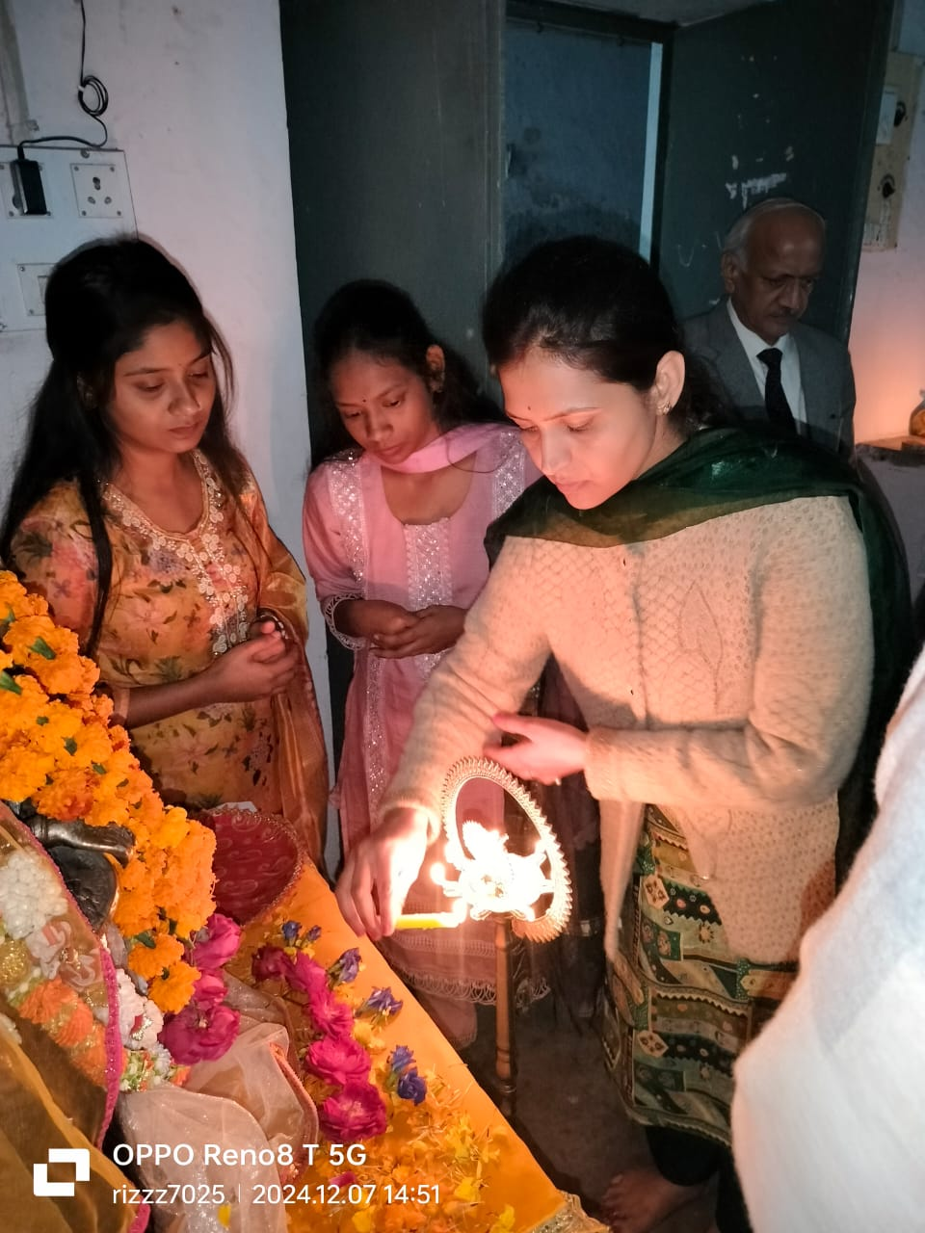

Later the programme was carried forward with welcoming the chief guest ( Mr. M,R. Gautam HOD , ART department LLR Hospital , Kanpur) and guest of honour ( Mrs Beena Sachan , matron LLR Hopsital Kanpur), (Mrs Sunita Yadav, matron LPS, Kanpur) and Mrs. Indrawati Devi( ANS), Mrs. Rebecca Wilkinson (Sister incharge), Mrs lajja wati ( sister incharge) LLR hospital, kanpur.

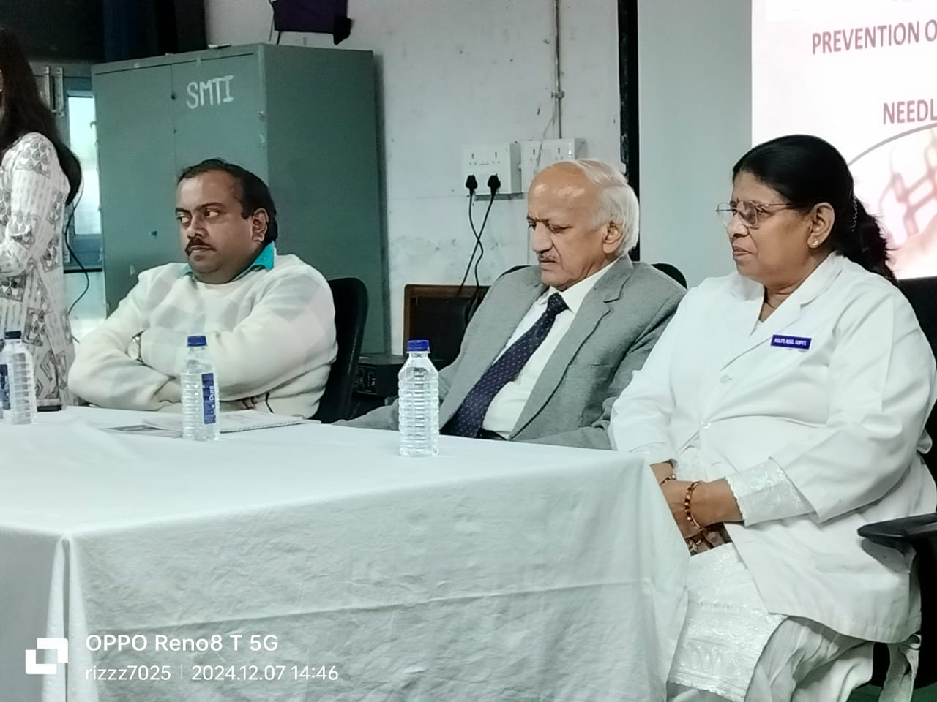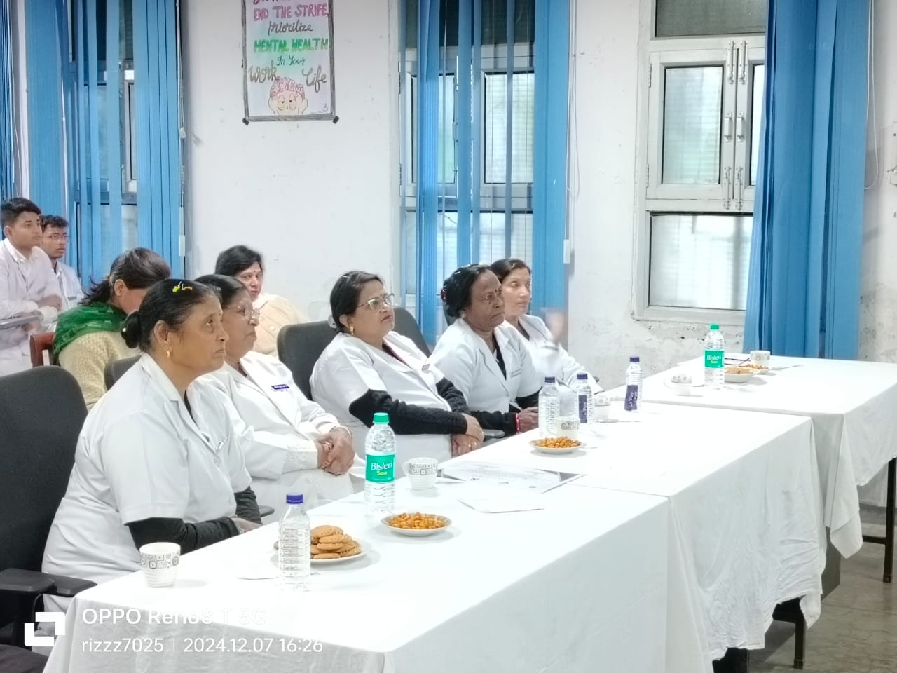

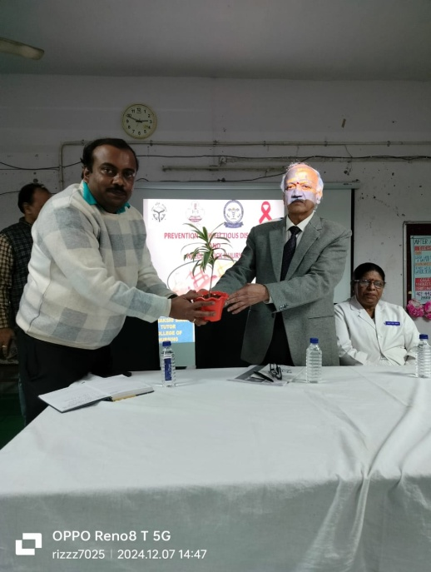 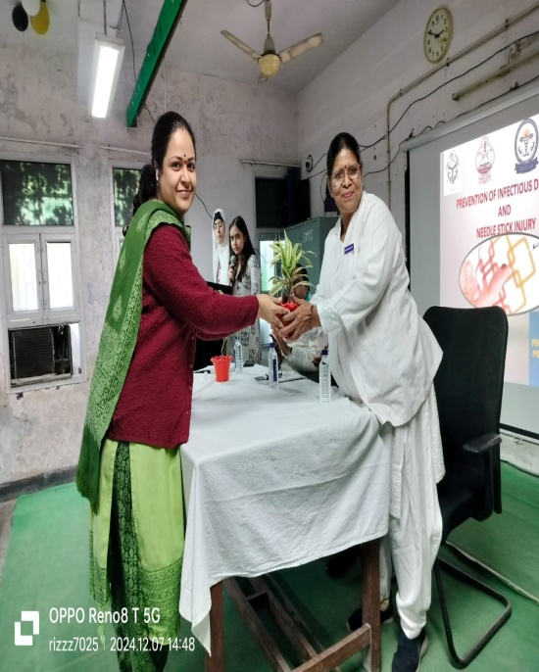 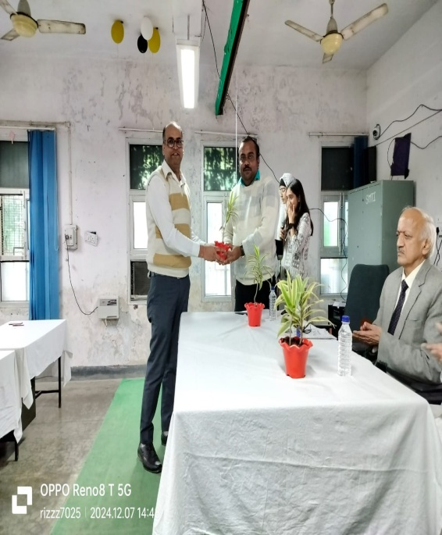

The guest were warm welcomed by Prof. Dr. Naveena J.H, Prof Namita Batra and Mr. Subhash Sharma Assosciate Professor, College Of Nursing, Kanpur with a plant sapling with the continuation of that Mr. M. R Gautam sir presented a guest lecture on PEP( post exposure prophylaxis). He delivered a lecture regarding the PEP in which he discussed about the infectious disease through the needle stick injury. In continuation with that students had an interaction with sir regarding the diseases that may occur through the needle stick injury, its prevention and how it can be managed.

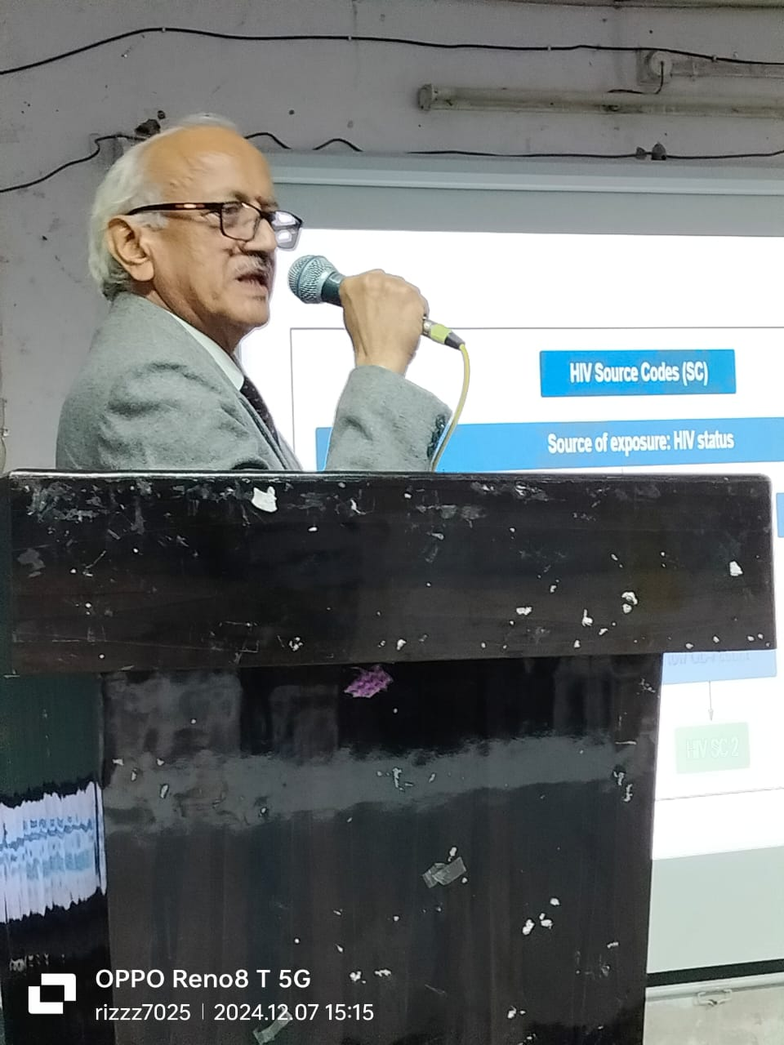 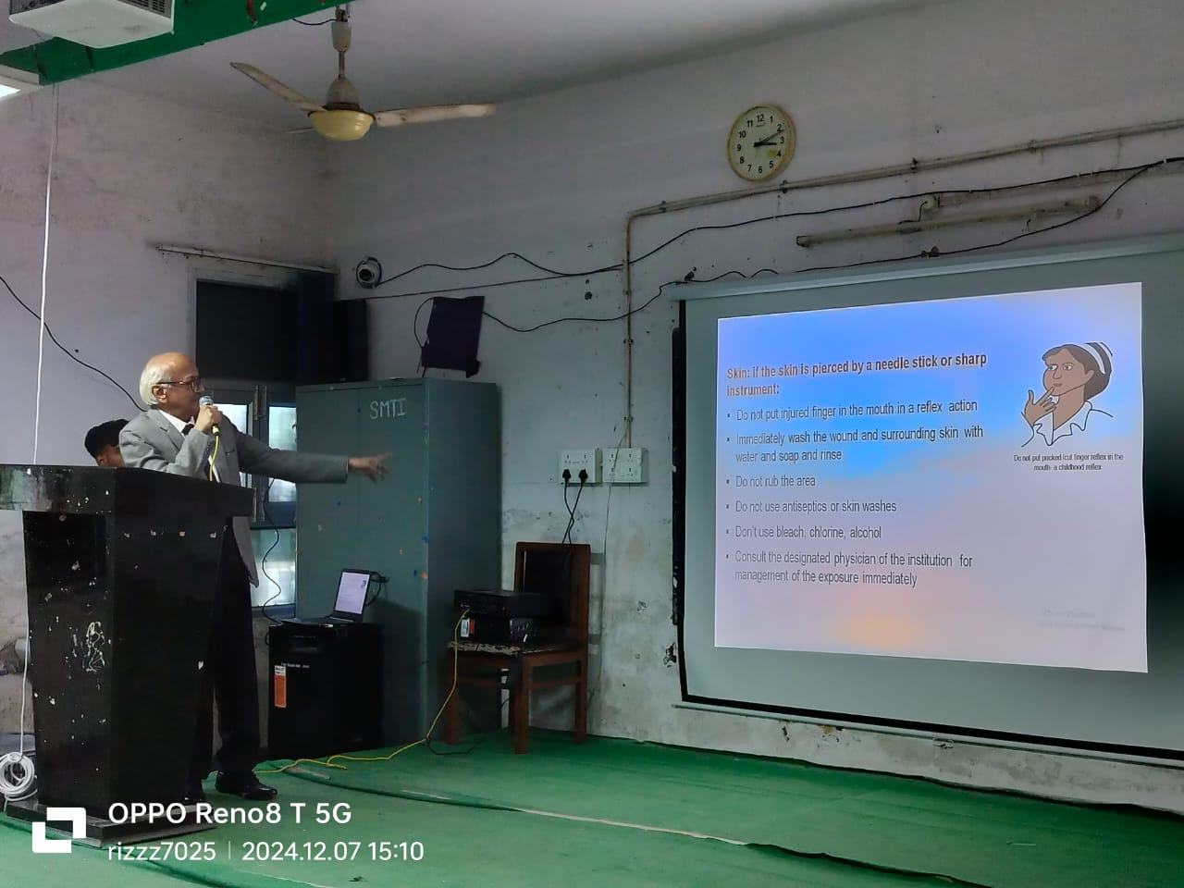

With the continuation of the programe Mrs.Beena Sachan (matron, LLR Hospital) discussed regarding the NSI (needle stick injury) in the hospital setting . NSI may be prevented by following the rules and regulations, standards of protocol.

Mrs Sunita Yadav, matron LPS, Kanpur contributed by delivering the lecture on the PEP. Post exposure prophylaxis is initially given to the clients who got NSI (needle stick injury).

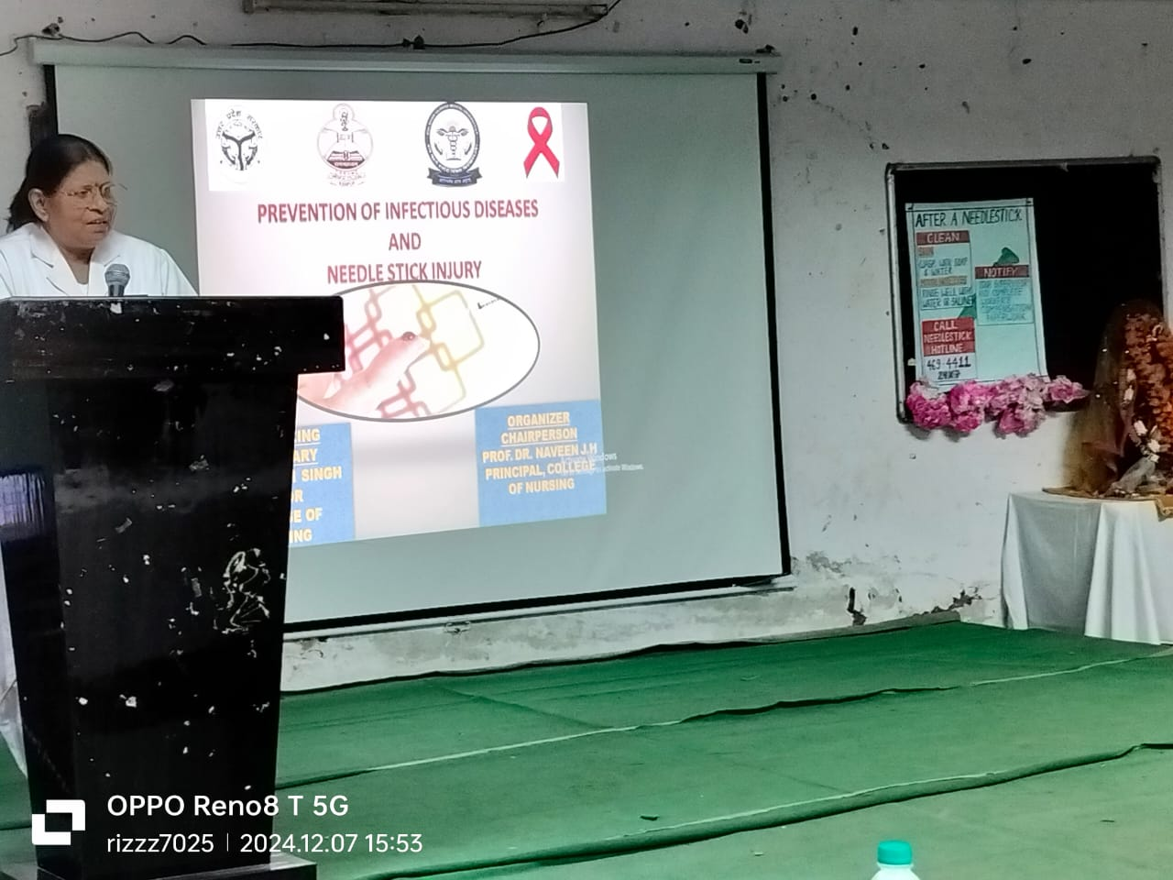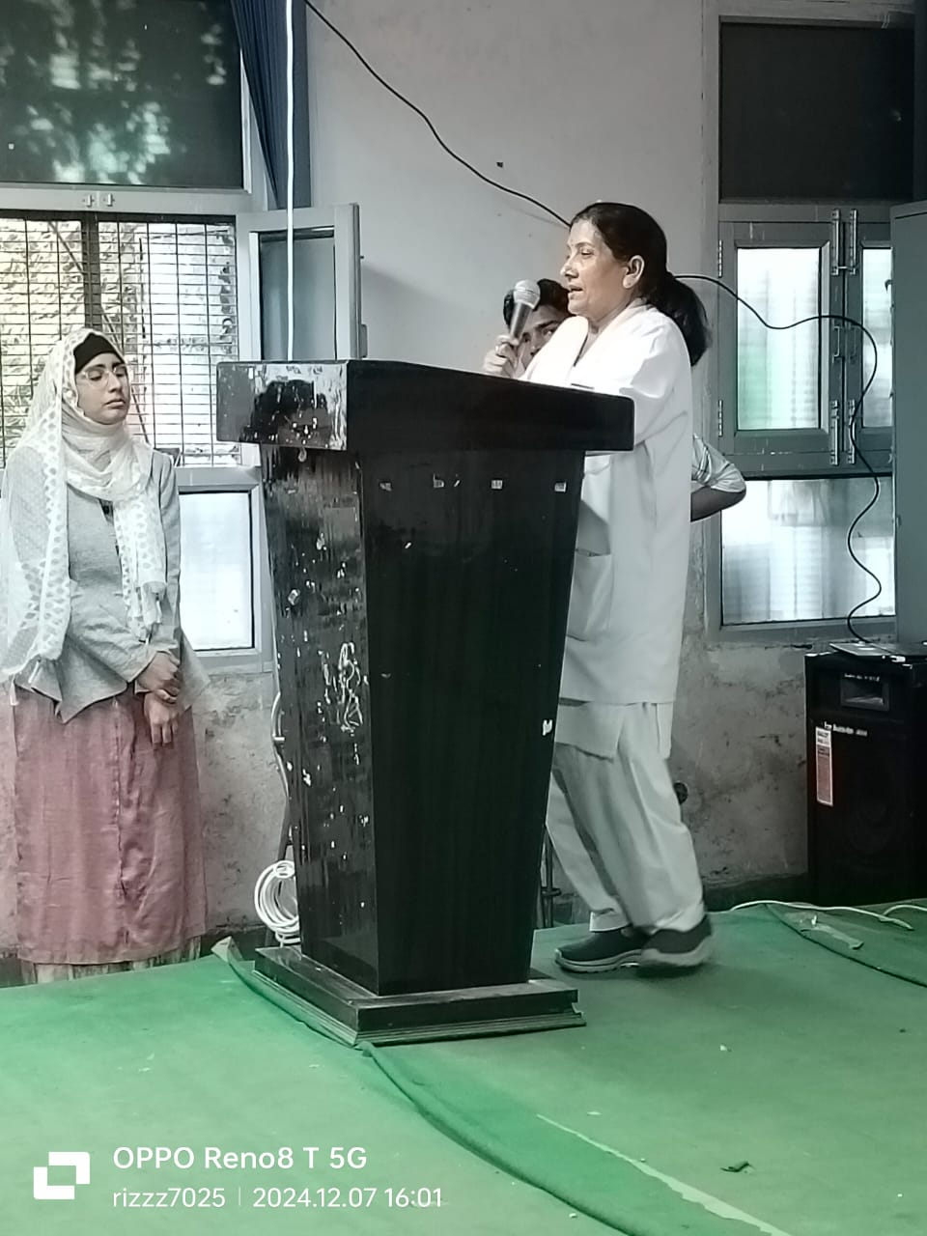

After delivering the guest lecture respected guest representative received certificate through the faculty of college of nursing.

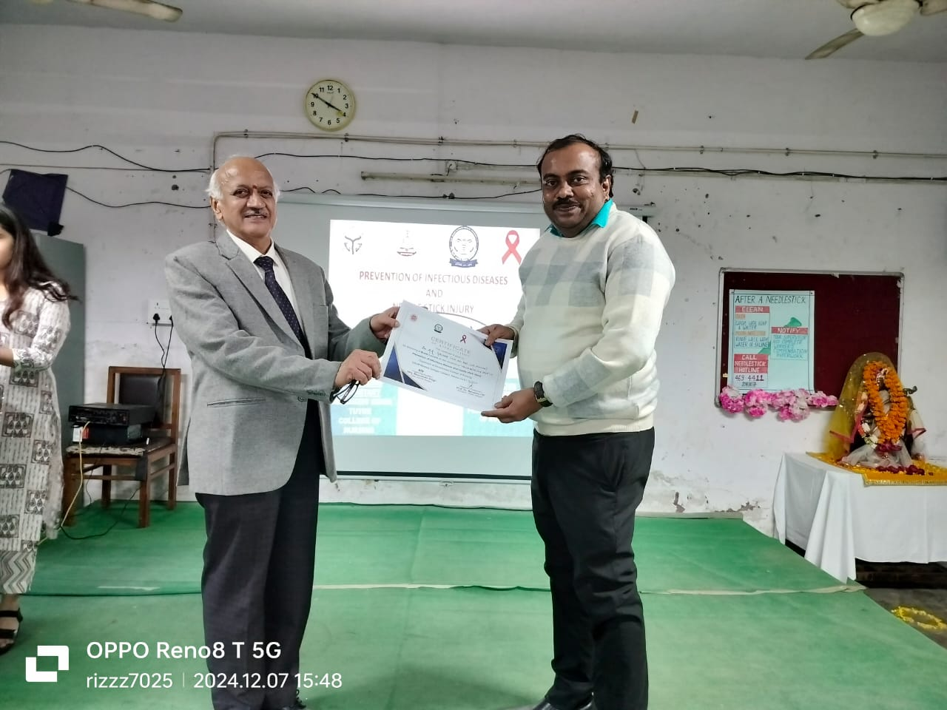 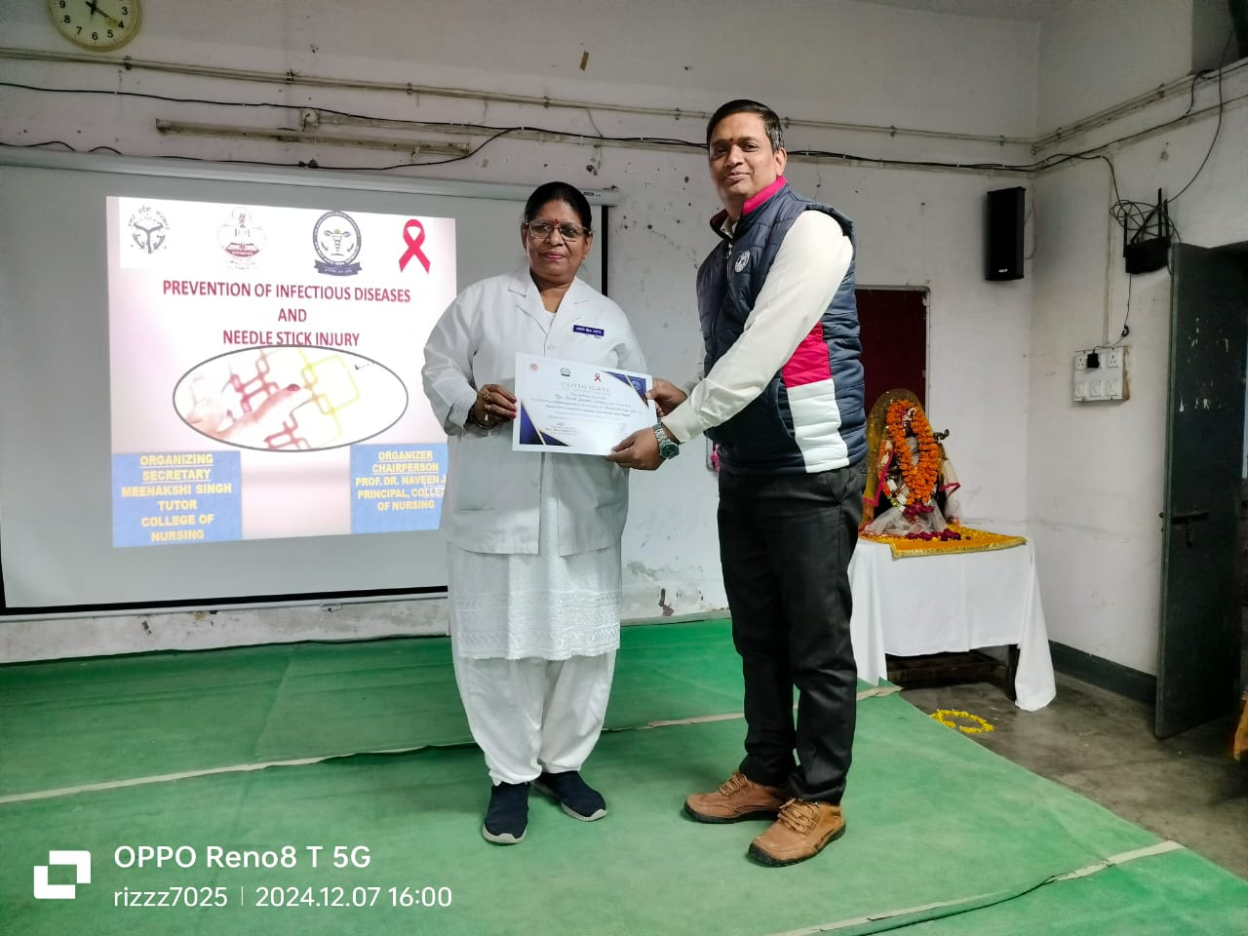 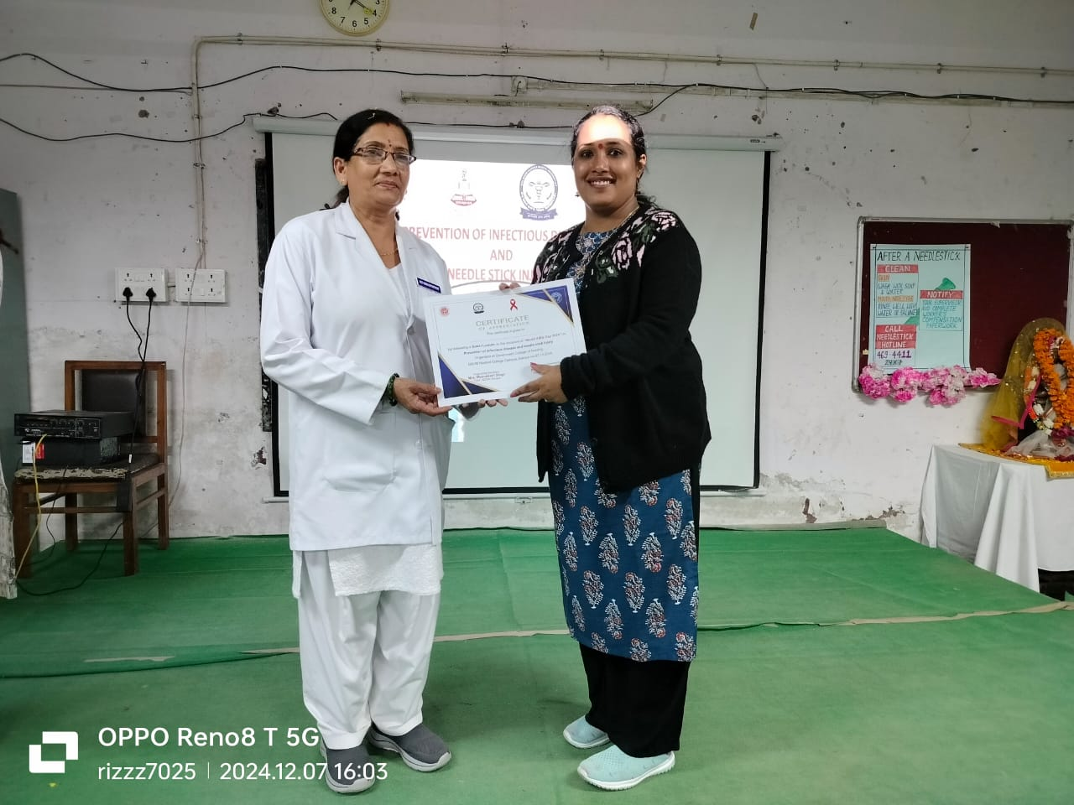

Students were encouraged with the warm words by Prof. Dr. Naveena J.H to follow the guidelines regarding the prevention of infection. He encouraged students to avoid re capping the needles as it the leading cause of getting needle stick injury.

One should be firmly follow the guidelines regarding the care of patients in the hospital setting.

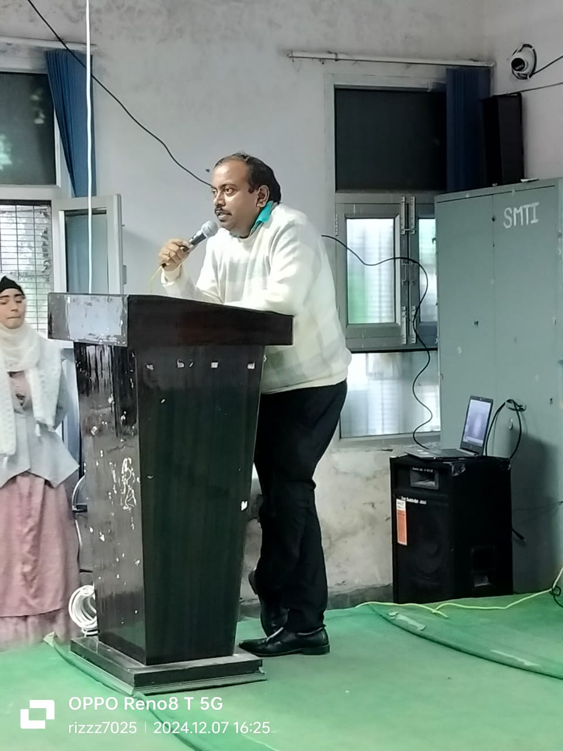 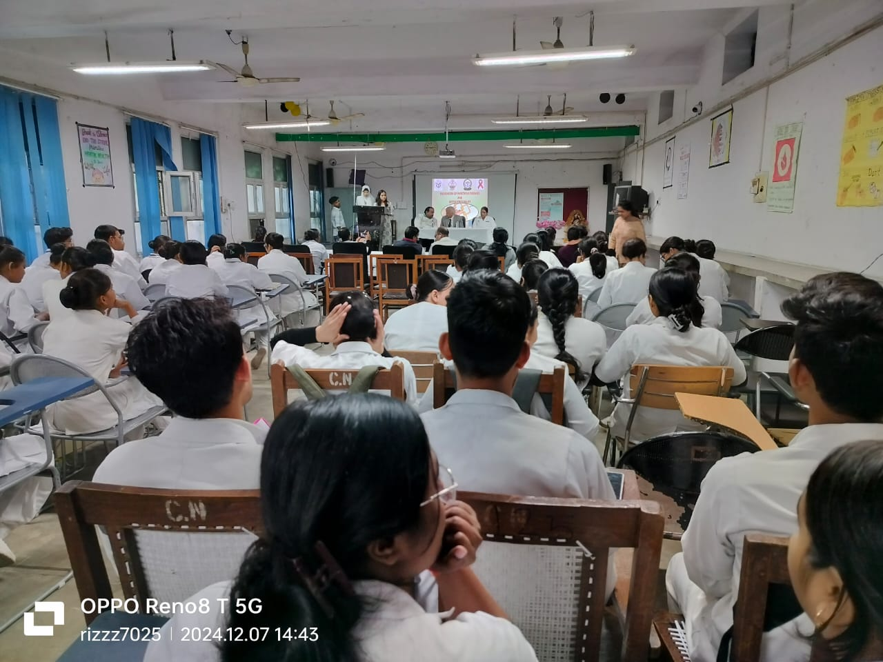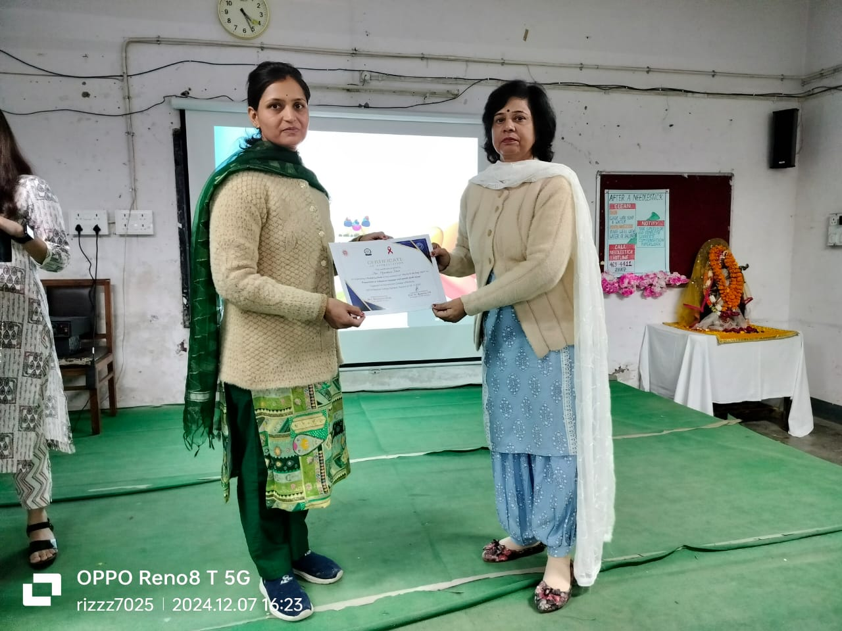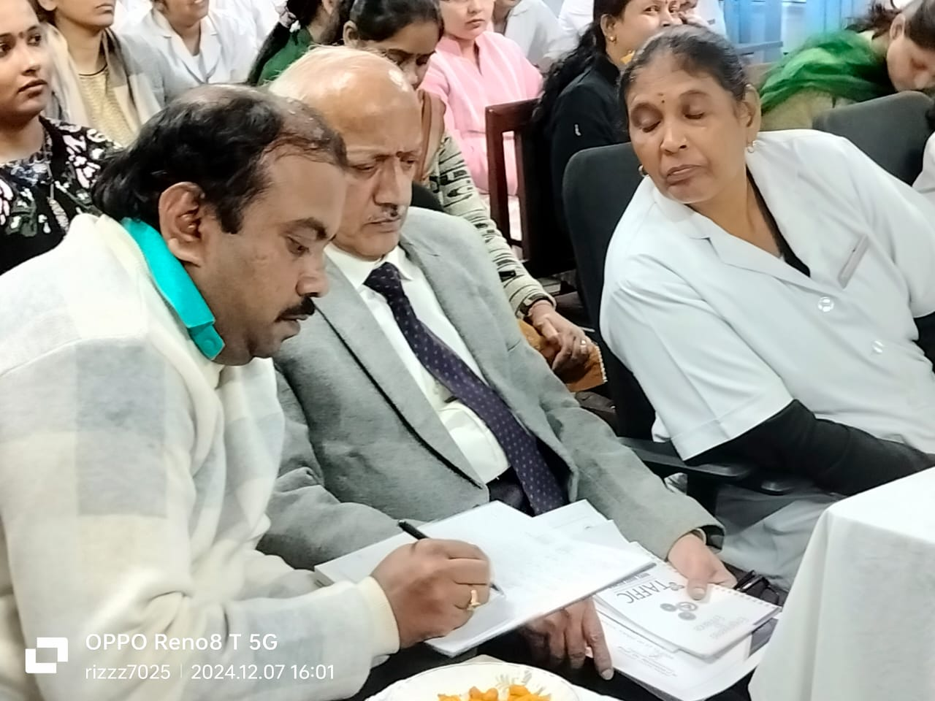

As the programme was ended by giving a thanks speech by Mrs Meenakshi Singh Tutor, College of nursing. She added up thanking to the guest of honour Mr M.R Gautam (HOD of ART department of LLR hospital, Kanpur) guest of honor, Mrs Beena Sachna, Matron LLR hospital, Mrs Sunita Yadav, Matron LPS Cardiology, Kanpur and special guest Mrs. Indrawati Devi( ANS), Mrs. Rebecca Wilkinson (Sister Incharge), Mrs lajja wati ( sister incharge) LLR hospital, Kanpur.

She added up contributing a special thanks to Principal College of nursing Prof. Dr. Naveena J.H, as organizing chairperson and giving an opportunity to organize this program me to create awareness among the nursing students regarding the prevention of infectious disease and needle stick injury.

All the faculty and students of B.Sc Nursing 4 th semester were given a special thanks for contributing in this programme. The programme was binded up by creating a healthy and fruitfull feedback.